**Project 3**

**1. Rewrite a common use case for each user story. Sketch the screens the system should display in each use case.**

<User>

|  |  |  |  |  |  |  |
| --- | --- | --- | --- | --- | --- | --- |
| Change my password and/or full name:   |  |  |  | | --- | --- | --- | | Username |  |  |  |  |  |  | | --- | --- | --- | | Password |  |  |   Manage User  Logout  Login |

<Admin>

|  |  |  |  |  |  |  |  |  |  |  |  |  |  |
| --- | --- | --- | --- | --- | --- | --- | --- | --- | --- | --- | --- | --- | --- |
| Home main screen:  Store Management System  Admin Information: Name, current date/time    Add a new User  Manage  a User  Add a new  Purchase  Delete an Existing  User | Add a new User:   |  |  |  | | --- | --- | --- | | Username |  |  | | Password |  |  | | Full Name |  |  | | User Type |  |  |   Cancel  Add |
| Manage a new User:  Save User  Load User   |  |  |  | | --- | --- | --- | | Username |  |  | | Password |  |  | | Full Name |  |  | | User Type |  |  | | Add a new Purchase:   |  |  |  | | --- | --- | --- | | PurchaseID |  |  | | CustomerID |  |  | | ProductID |  |  | | Quantity |  |  |   Cancel  Add |
| Delete an Existing User:   |  |  |  | | --- | --- | --- | | Username |  |  |   Cancel  Delete |  |

<Manager>

|  |  |  |  |  |  |  |  |  |  |  |  |  |  |  |  |  |  |  |  |  |  |  |  |  |  |
| --- | --- | --- | --- | --- | --- | --- | --- | --- | --- | --- | --- | --- | --- | --- | --- | --- | --- | --- | --- | --- | --- | --- | --- | --- | --- |
| Add a new Product:   |  |  |  | | --- | --- | --- | | ProductID |  |  | | Name |  |  | | Price |  |  | | Quantity |  |  |   Cancel  Add | Manage Products:  Save Product  Load Product   |  |  |  | | --- | --- | --- | | ProductID |  |  | | Name |  |  | | Price |  |  | | Quantity |  |  | |
| Manage Customer:  Save Customer  Load Customer   |  |  |  | | --- | --- | --- | | CustomerID |  |  | | Name |  |  | | Phone |  |  | | Address |  |  | | All purchases history:   |  |  |  |  | | --- | --- | --- | --- | | PurchaseID | ProductID | Product name | Total | |  |  |  |  | |  |  |  |  | |  |  |  |  | |  |  |  |  | |  |  |  |  | |  |  |  |  | |  |  |  |  | |

<Cashier>

|  |  |  |  |  |  |  |  |  |  |  |  |  |  |
| --- | --- | --- | --- | --- | --- | --- | --- | --- | --- | --- | --- | --- | --- |
| Home main screen:  Store Management System    Add a new Purchase  Add a new Customer  Make Existing Customer | Add Customer:   |  |  |  | | --- | --- | --- | | CustomerID |  |  | | Name |  |  | | Phone |  |  | | Address |  |  |     Cancel  Add |
| Manage Customer:  Save Customer  Load Customer   |  |  |  | | --- | --- | --- | | CustomerID |  |  | | Name |  |  | | Phone |  |  | | Address |  |  | | Add a new Purchase:   |  |  |  | | --- | --- | --- | | PurchaseID |  |  | | CustomerID |  |  | | ProductID |  |  | | Quantity |  |  |   Cancel  Add |

<Customer>

|  |  |  |  |  |  |  |  |  |  |  |  |  |  |  |  |  |
| --- | --- | --- | --- | --- | --- | --- | --- | --- | --- | --- | --- | --- | --- | --- | --- | --- |
| Home main screen:  Store Management System  Customer Information: Name, current date/time    Search Product  Cancel a Purchase  View Purchase History  Make a purchase | Make a Purchase:   |  |  |  | | --- | --- | --- | | PurchaseID |  |  | | Quantity |  |  | | Price |  |  | | Tax |  |  | | Total Price |  |  |   Cancel  Add |
| Purchase history:   |  |  |  | | --- | --- | --- | | Date | PurchaseID | More info… | |  |  |  | |  |  |  | |  |  |  | |  |  |  | |  |  |  | |  |  |  | |  |  |  | | Cancel a Purchase:   |  |  |  | | --- | --- | --- | | PurchaseID |  |  |   Cancel a Purchase  Cancel |
| Search Product:   |  |  |  |  | | --- | --- | --- | --- | | ProductID | Product Name | Price | Quantity | |  |  |  |  | |  |  |  |  | |  |  |  |  | |  |  |  |  | |  |  |  |  | |  |  |  |  | |  |  |  |  | |  |

**2. Redesign the client and server components to support all those transactions.**

User:

* I want to change my password and/or full name
* Made Manage User UI

Admin:

* I want to add a new user into the system.Add a new customer
* Made Add UI
* I want to update the type/class of a user into the system (e.g., from cashier to manager)
* Manage User UI

Manager:

* I want to add a new product or update a current product in the system
* Manage Product UI or Add Product UI
* I want to view a summary report of sales from the system
* Summary Purchase UI

Cashier:

* I want to add a new customer or update a current customer in the system
* Add Customer UI or Manage Customer UI
* I want to add a new purchase or update a current purchase (only price and quantity) in the system
* Add Purchase UI

Customer:

* I want to add a new purchase into the system
* Add Purchase UI
* I want to view my purchase history into the system
* Purchase History UI
* I want to search for product information (based on name, price) in the system
* Product Search UI

=> those classes will be in the java files

**Outputs**

Users

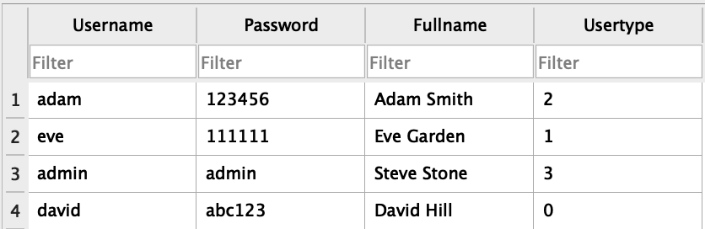

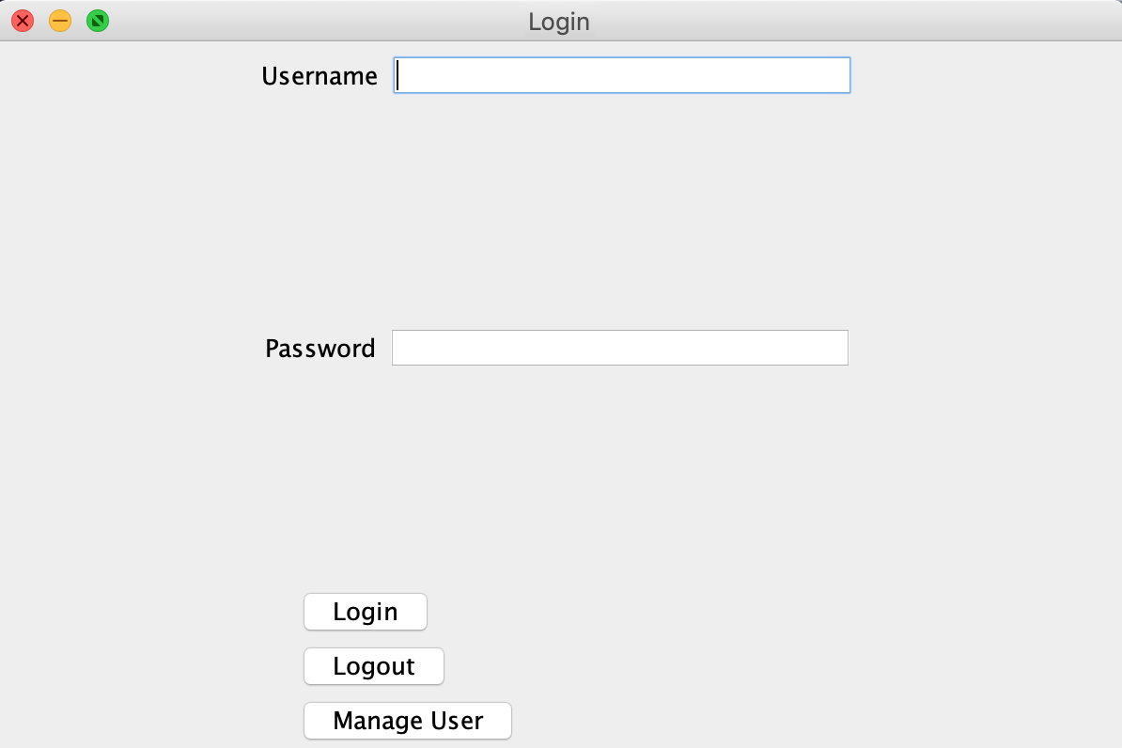

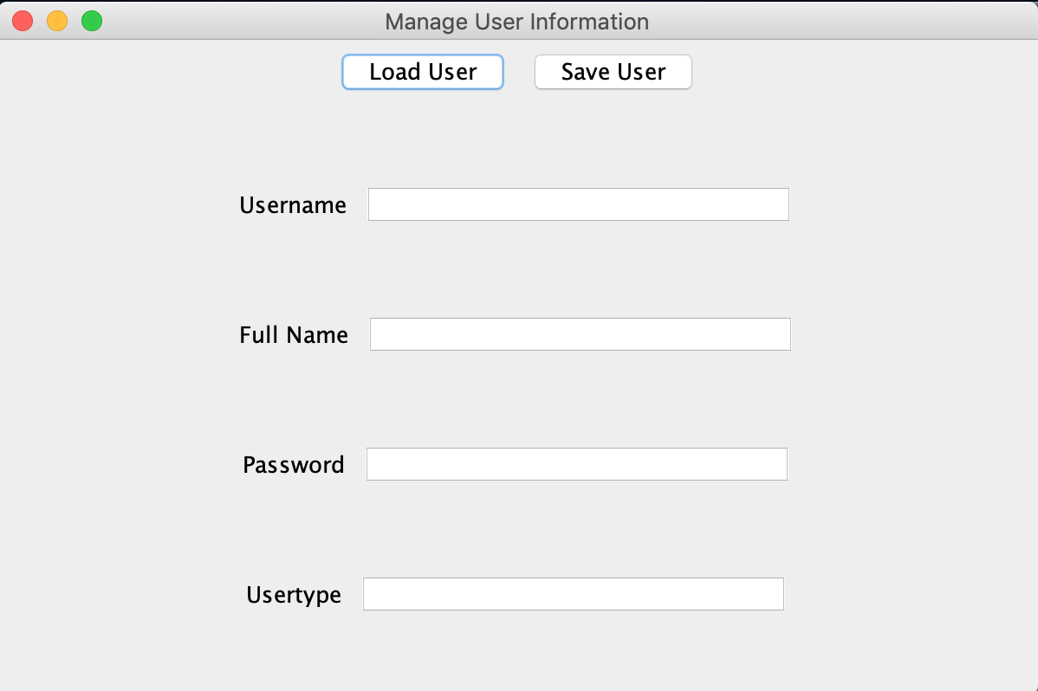

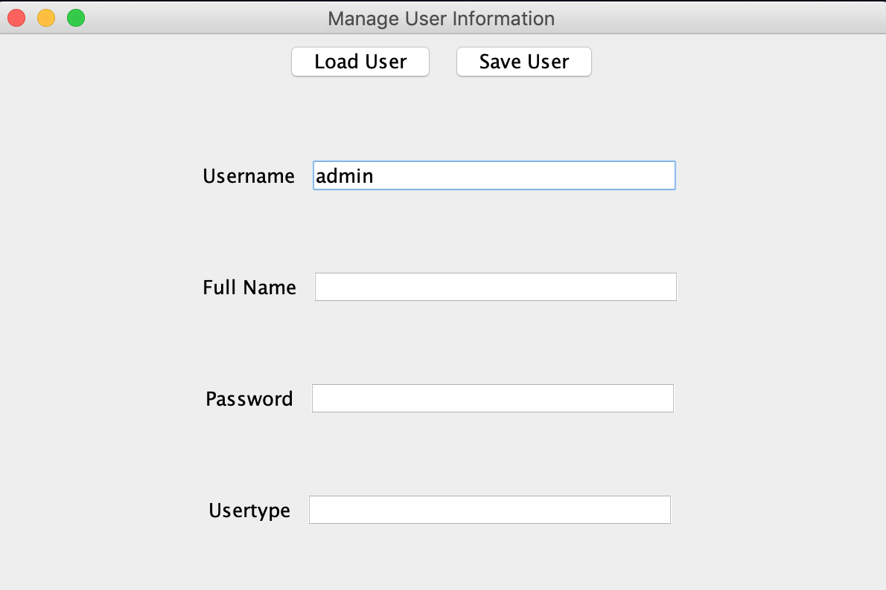

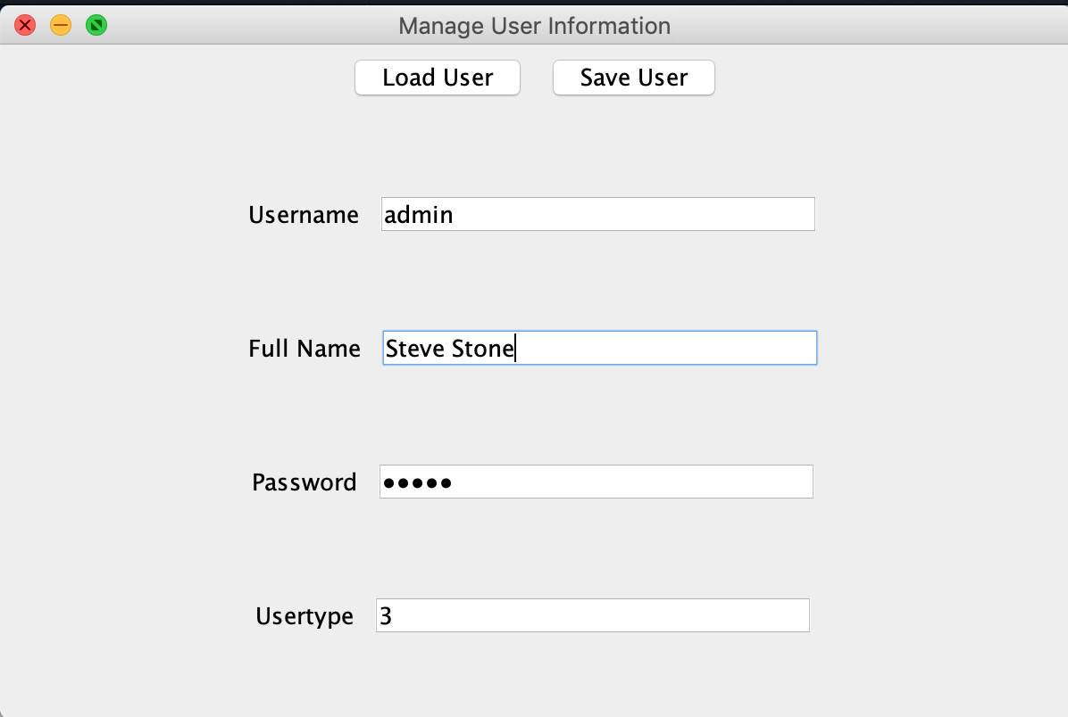

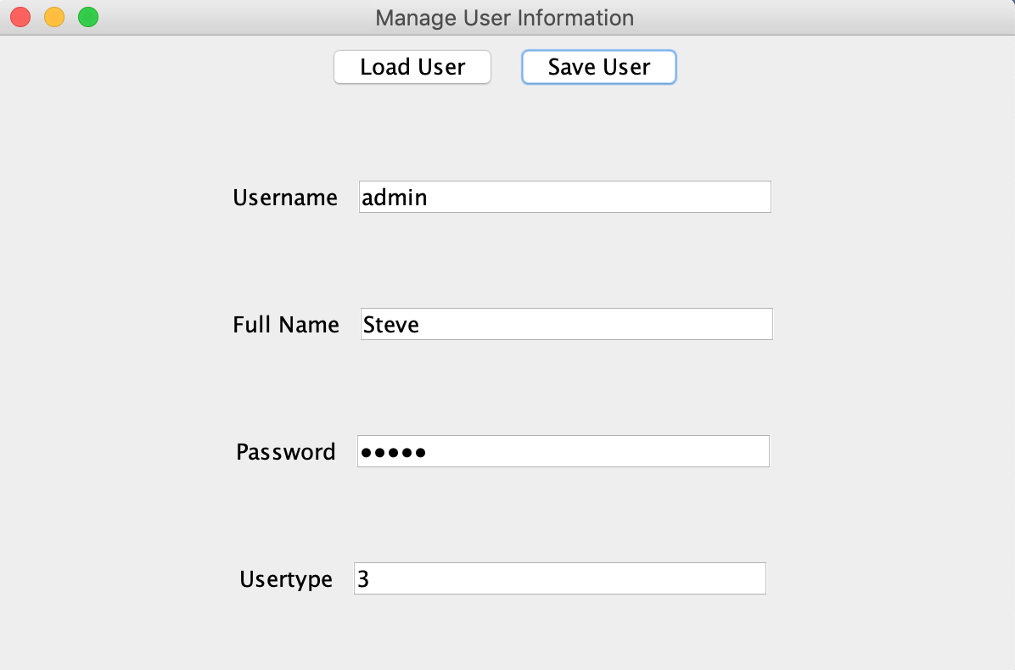

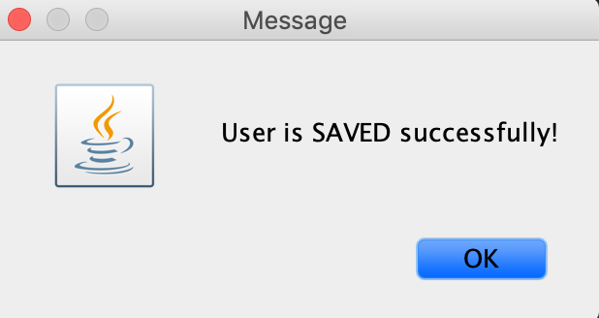

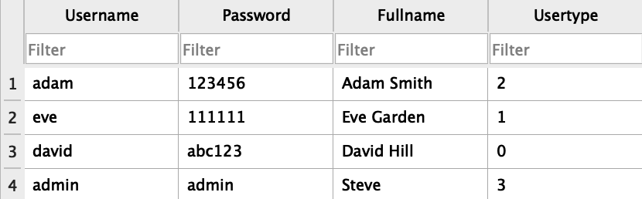

Admin

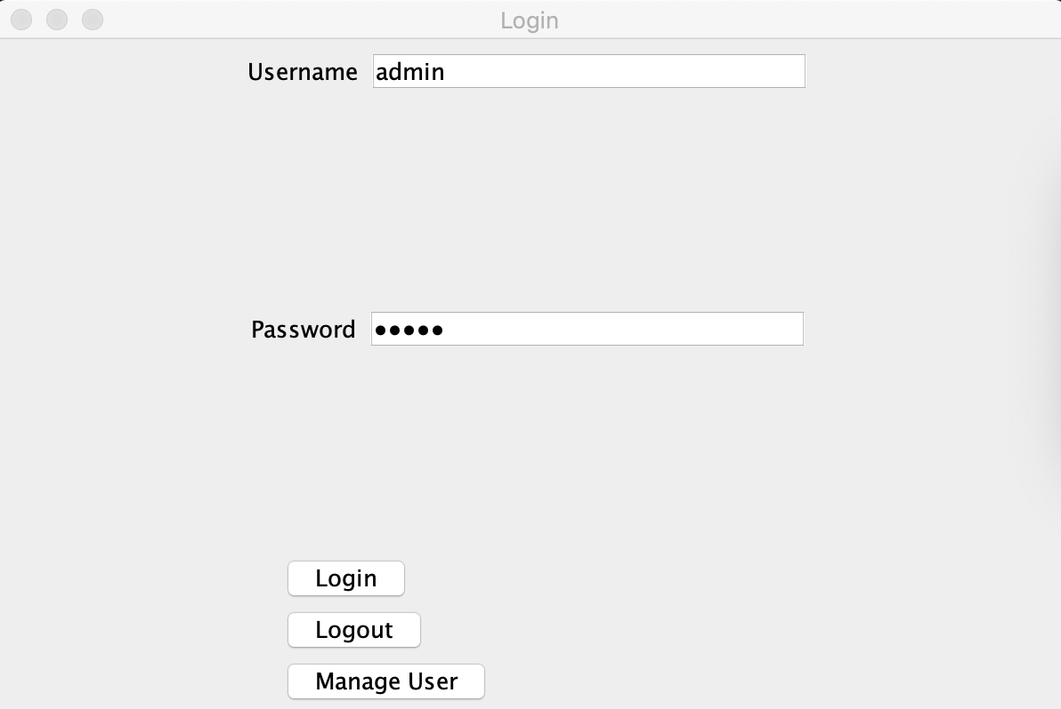

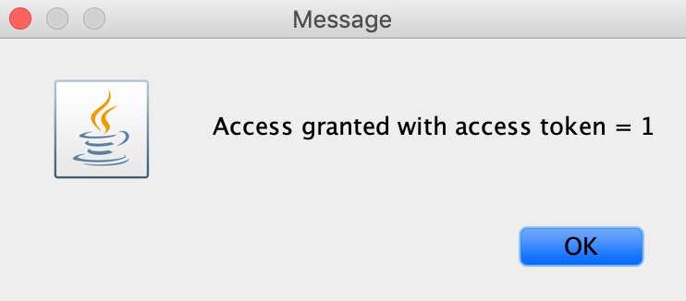

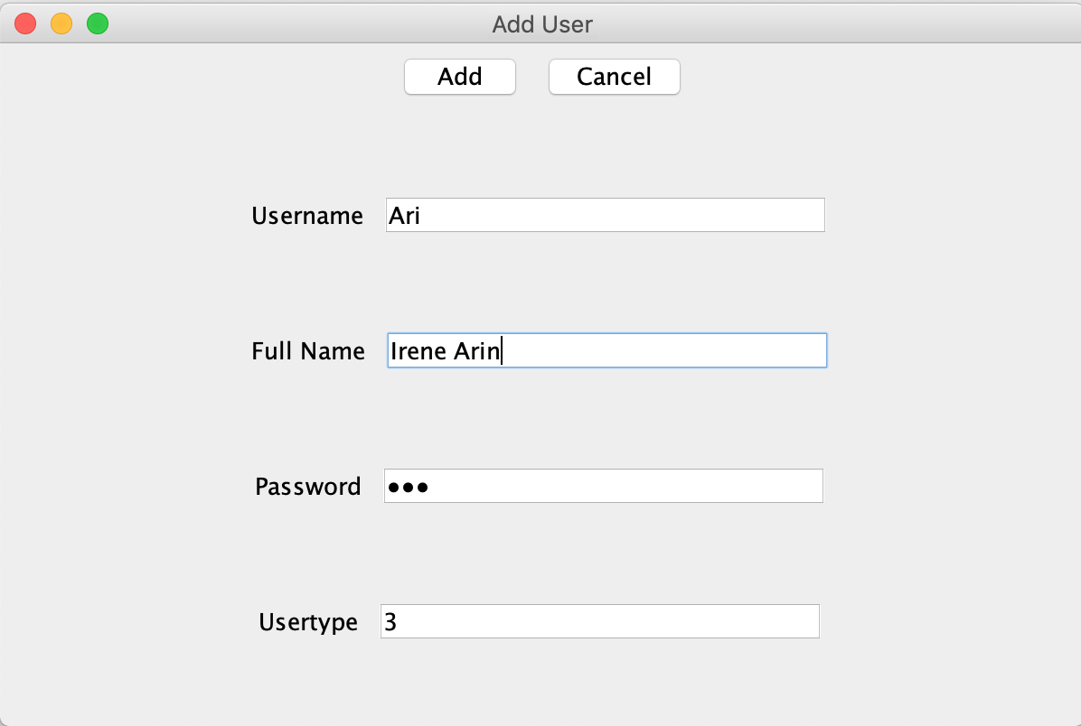

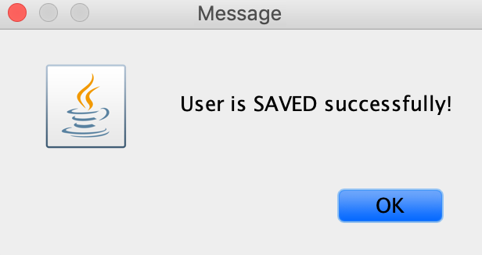

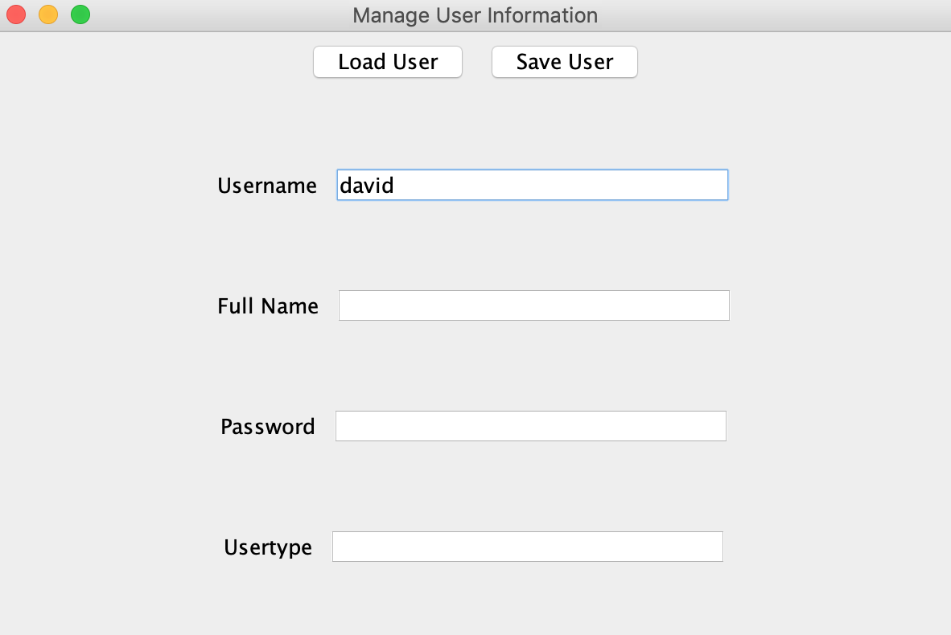

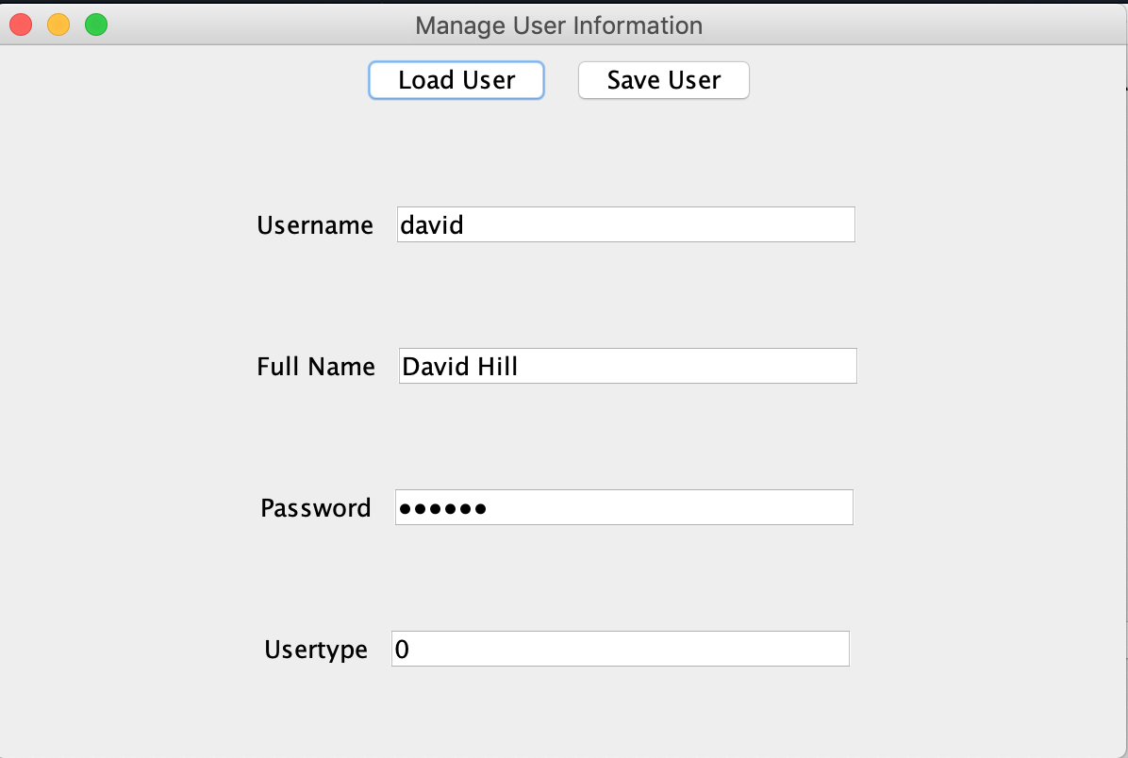

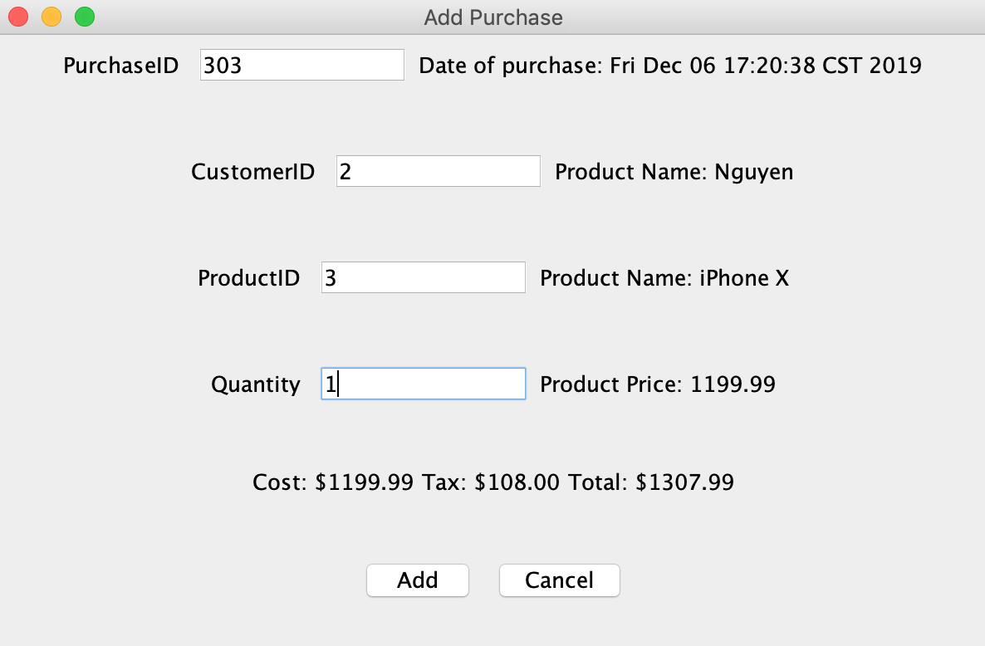

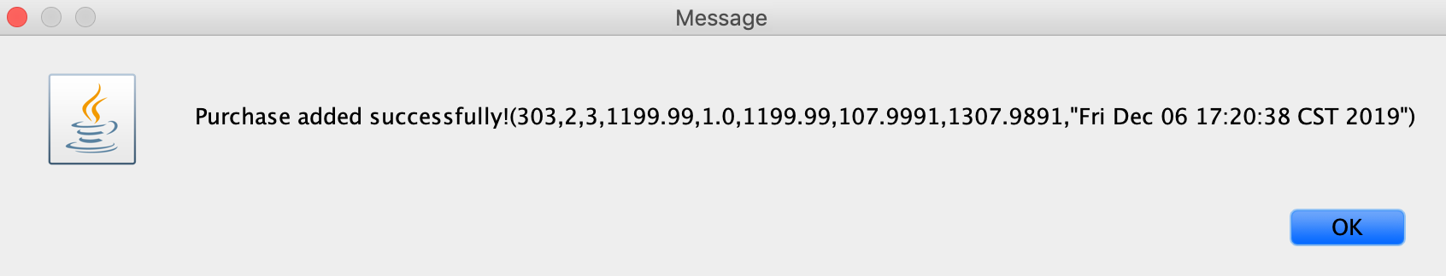

Manager

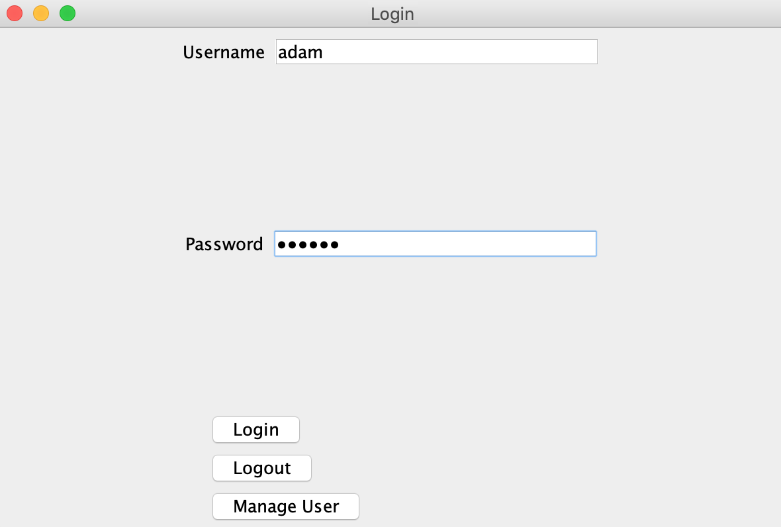

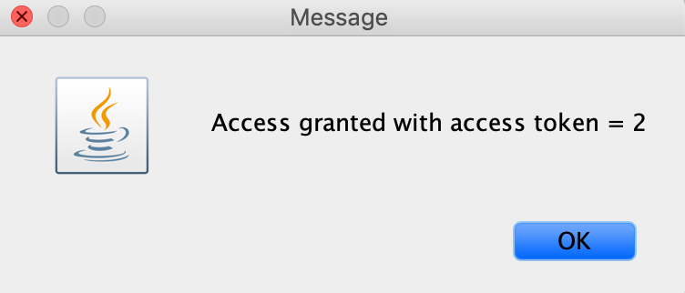

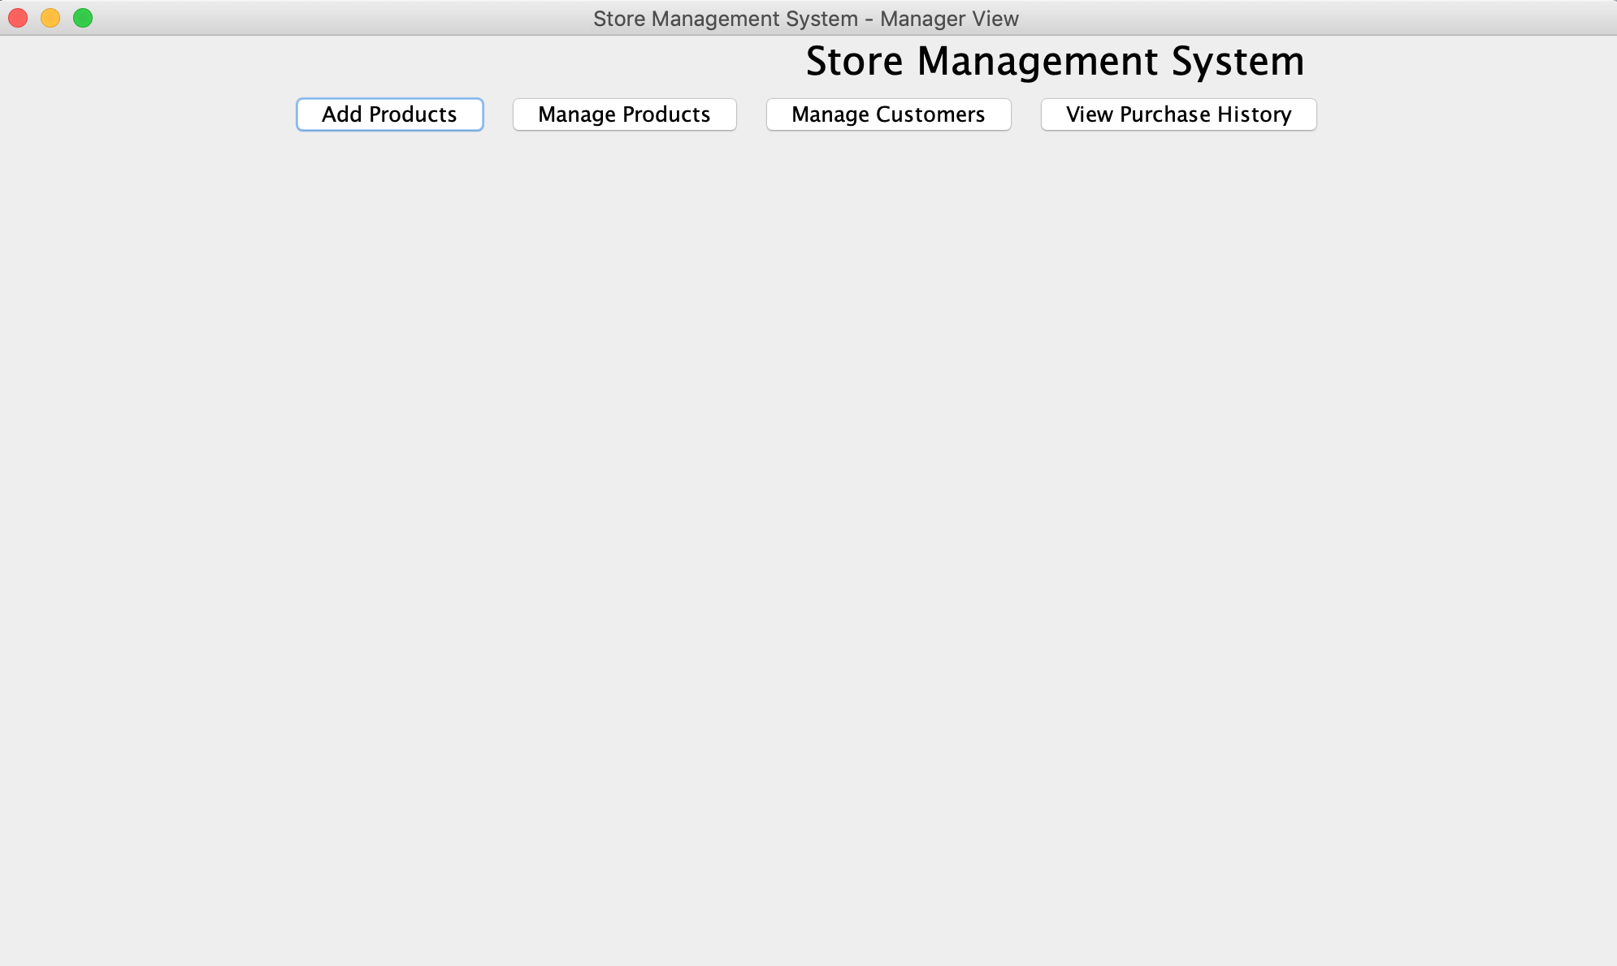

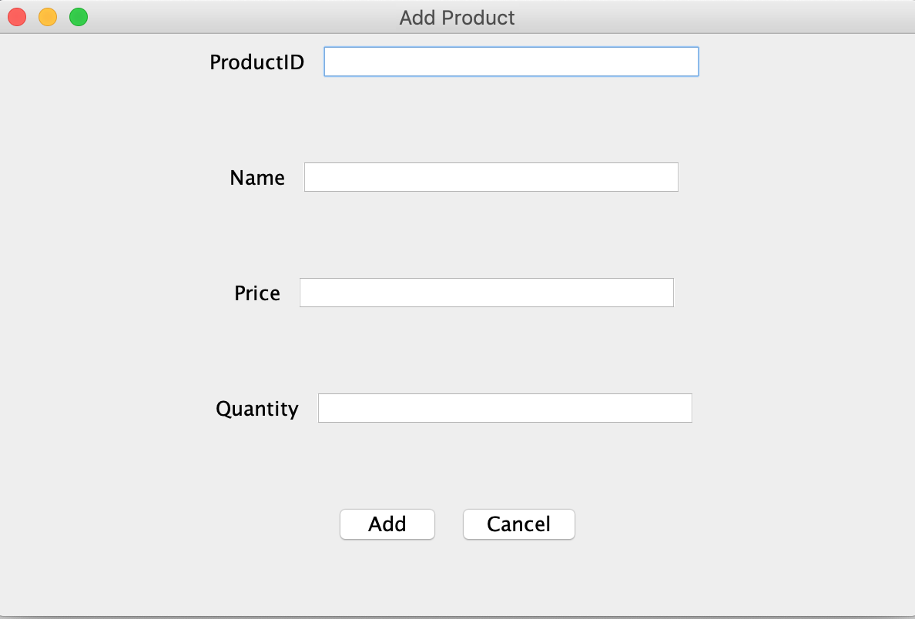

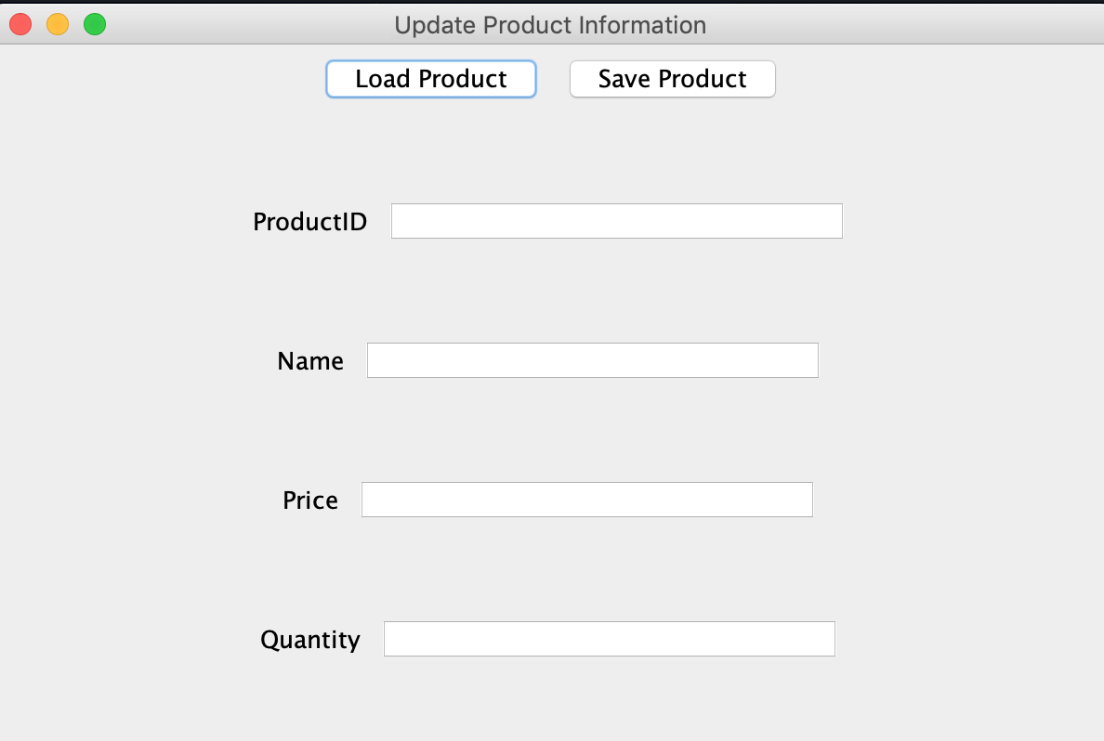

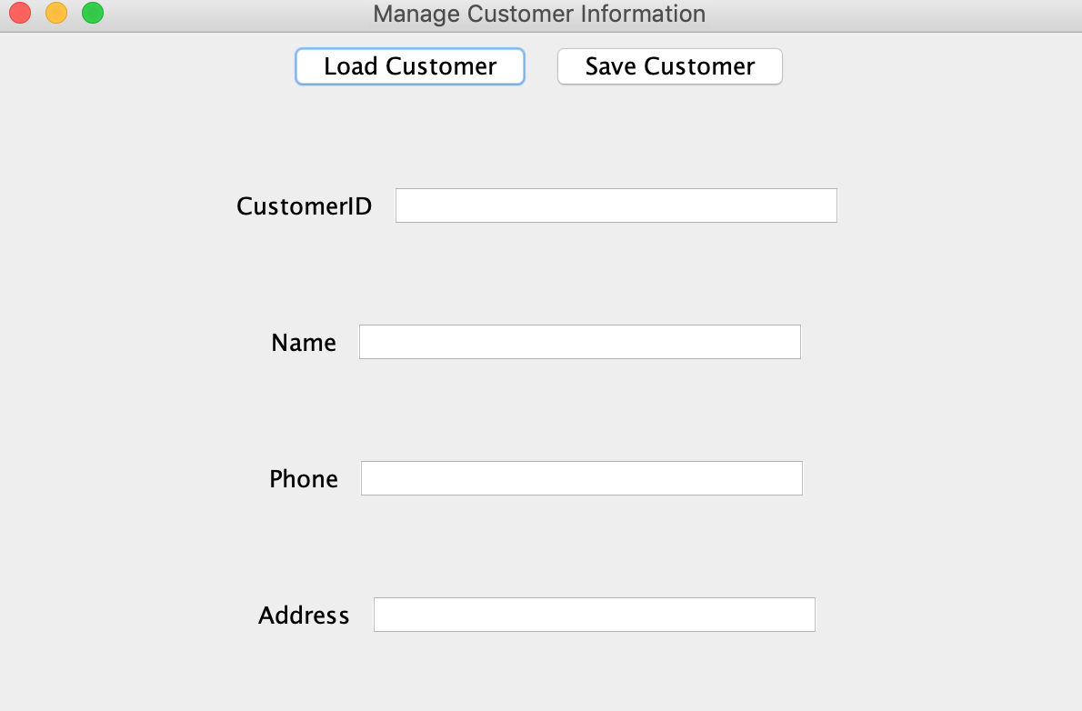

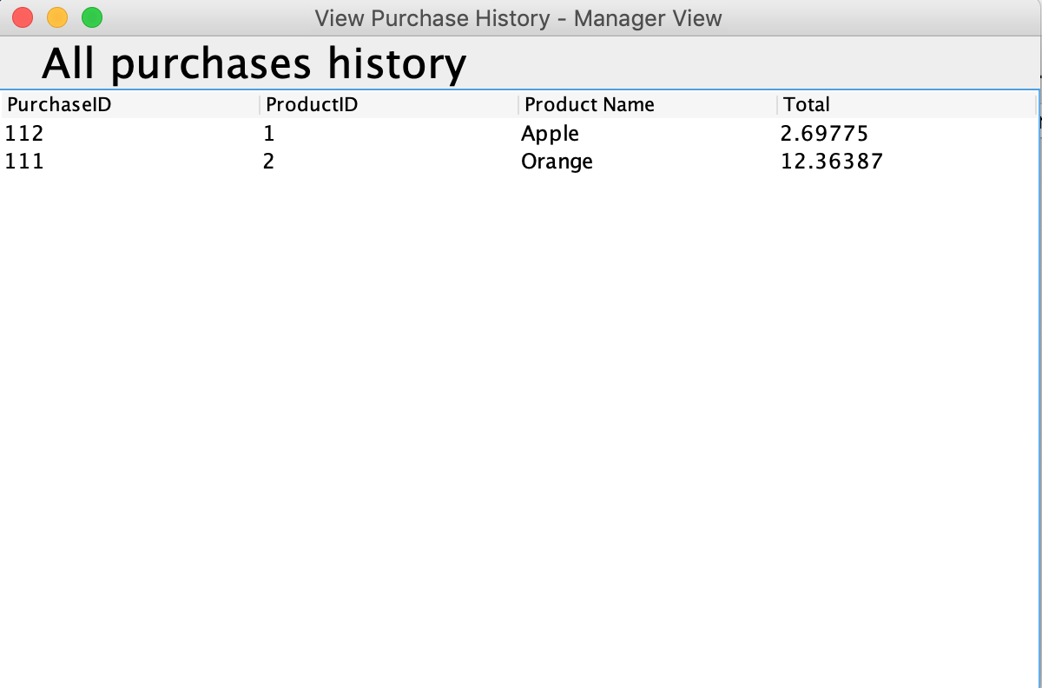

Cashier

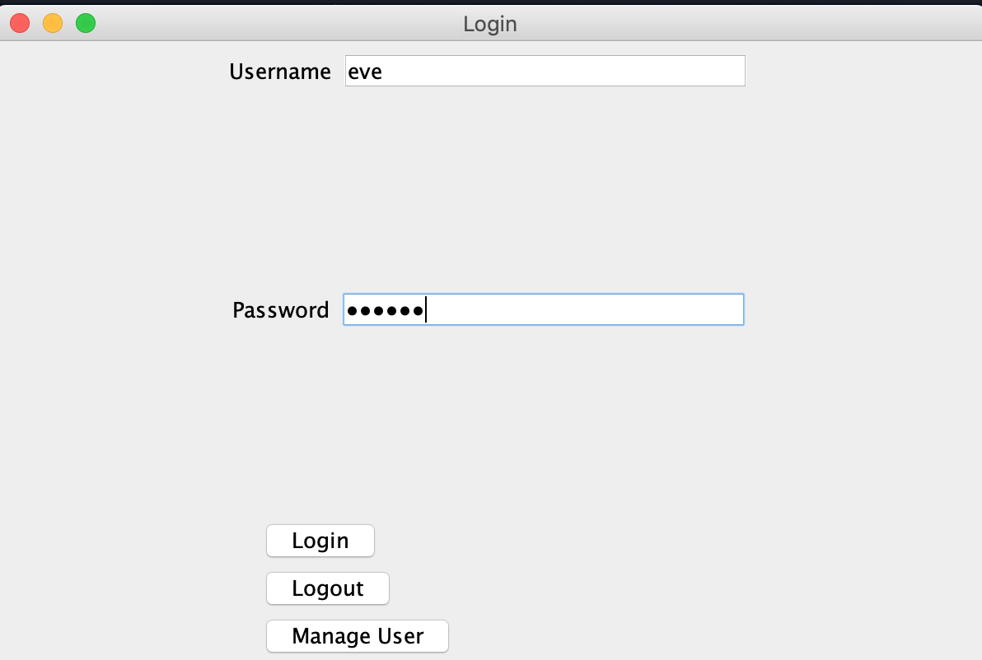

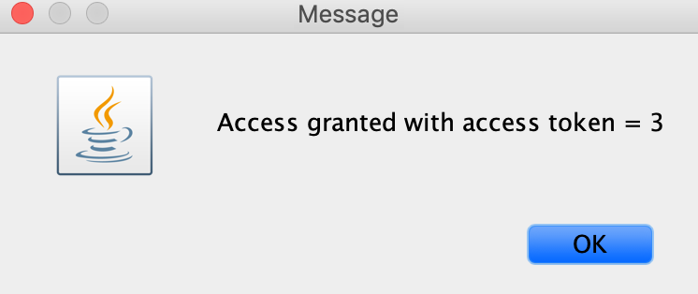

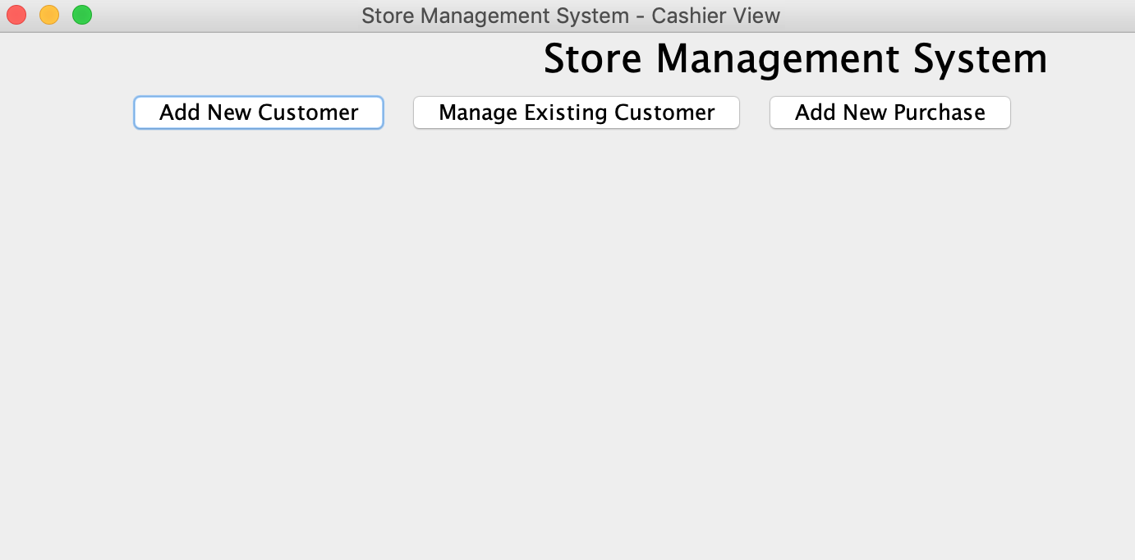

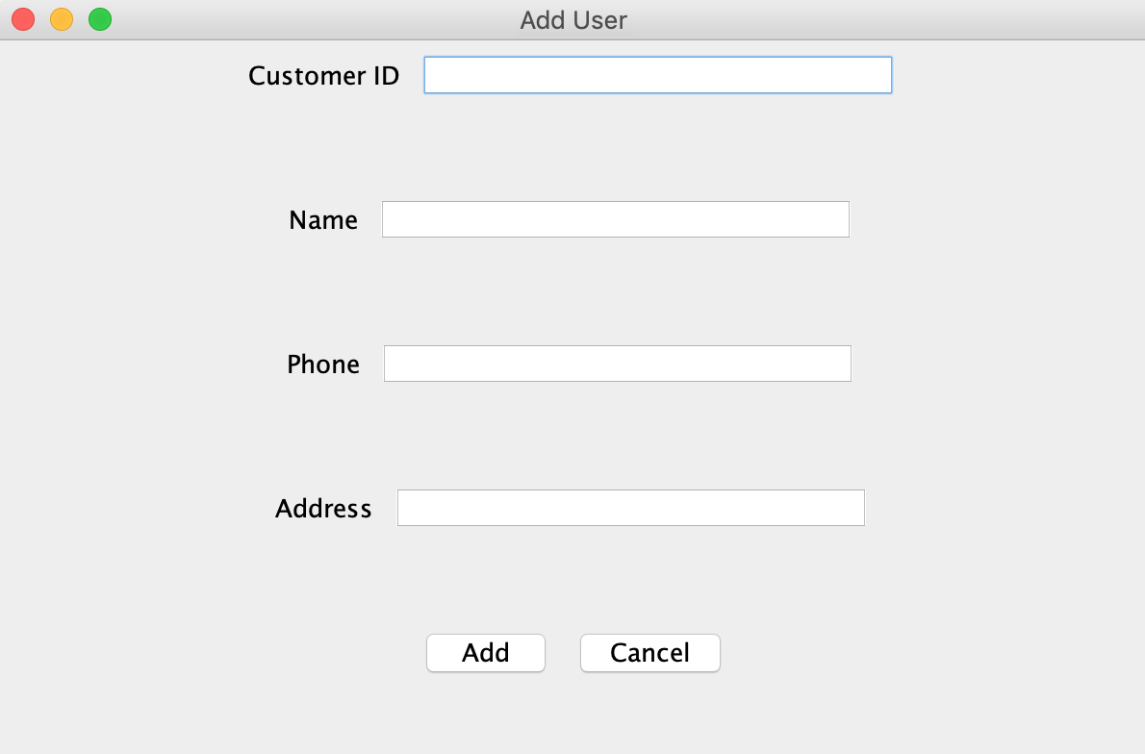

Customer

